Dr Margaret Hodgins.

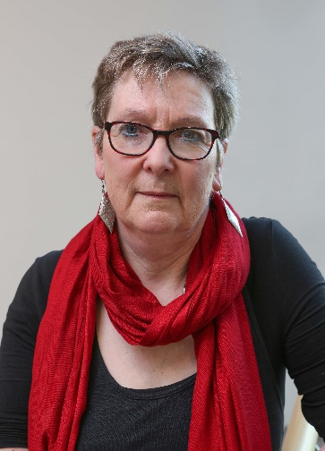
Dr. Hodgins is a member of the Discipline of Health Promotion and a Principal Investigator with the Health Promotion Research Centre.
She led on the 'Irish Workplace Behaviour Study' a national study on workplace bullying, violence and incivility, and has published on the topic of workplace bullying in public sectors organisations, SMEs and Universities. Margaret was Project Lead on the development of a blended learning CPD module, 'Workplace Wellness', 2017-2018. She is co-editor of a text book on Health Promotions Settings with Dr. Angela Scriven from Brunel University, and has recently co-authored a text on Workplace Health Promotion with Professor Paul Fleming (University of Southhampton) and Mr John Griffith (Work2Health, Cardiff).
Margaret graduated from Trinity College, Dublin, and after working in the private sector for a few years, moved over to the West to take up a lectureship NUI Galway, where she has worked since 1995. She is currently Director of the MA in Health Promotion, and also worked as Head of the School of Health Science between 2013 and 2017

